Χρήσεις Γης (Cultivated Agriculture)
Cover Description | Condition | CN | Area (km²)
Pasture, Grassland or range | Fair | A | 13.366
Brush –brush, weed, grass mix | Fair | B | 9.932
Olives (Woods – grass combination) | Fair | B | 9.813

Time of Concentration details
Flow Type | Length | Slope | Surface Manning n
Sheet | 22.0 | 0.2515 | Smooth surface (0.011)
Shallow Concentrated | 400.12 | 0.2515 | Unpaved

Flow Type | Length | Slope | n | Area (m²) | WP | Velocity (υπολογίζεται από το πρόγραμμα)
Channel | 10609.64 | 0.0365 | 0.03 | 5 | 6 | 5.635

Reach Name | Receiving Rch | Reach Length (m) | Manning n | Friction slope | Bottom Width (m) | Side slopes
KeramRch | Outlet | 7609 | 0.03 | 0.0365 | 5 | 2:1
Reach Data

Storm Data
Rainfall Distribution Type | Receiving Rch
Historical Storm | Outlet

Rainfall Return Period (yr) | 24-Hr Rainfall Amount (mm)
2 | 99.51
5 | 136.5
10 | 164.29
25 | 201.17
50 | 227.6
100 | 253.4
1 | 71.616

Custom Rainfall Distribution
Choose -> Historical Storm
Enter numbers:
0.00000 | 0.01351 | 0.04054 | 0.05743 | 0.08784
0.11824 | 0.19595 | 0.27027 | 0.34122 | 0.41216
0.54730 | 0.63514 | 0.72635 | 0.79392 | 0.87500
0.92568 | 0.95946 | 0.95946 | 0.96622 | 0.96959
0.96959 | 0.97973 | 0.99662 | 0.99950 | 1.00000

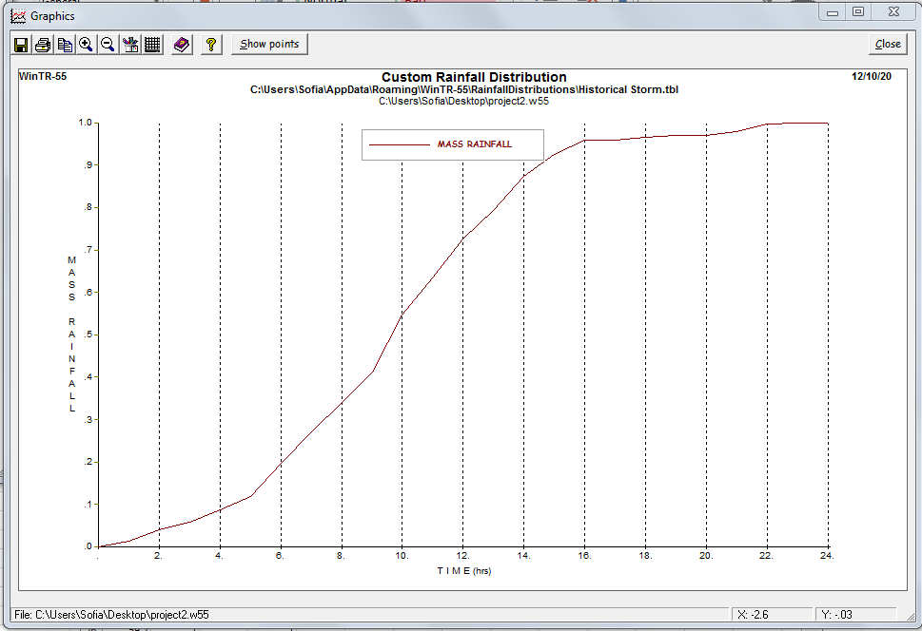

Dimensionless Unit Hydrograph
Rename to “Keramianos”
